Part 1:

First program:

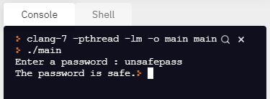

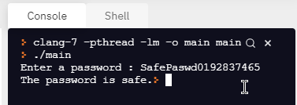

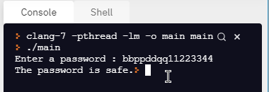

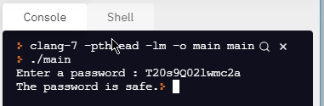

Second (updated) program:

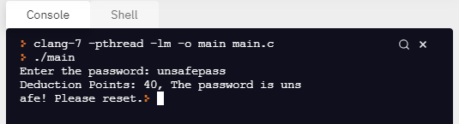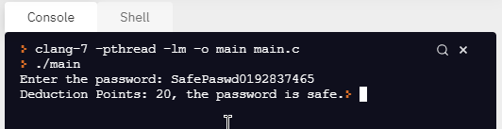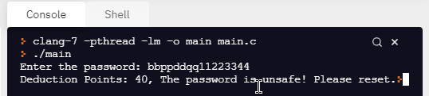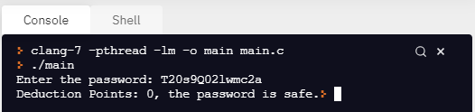

Part 2:

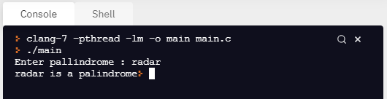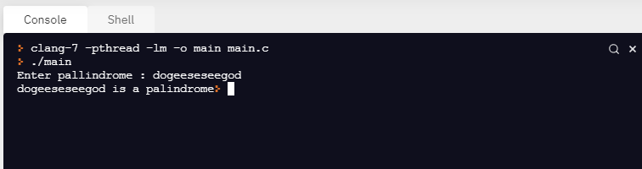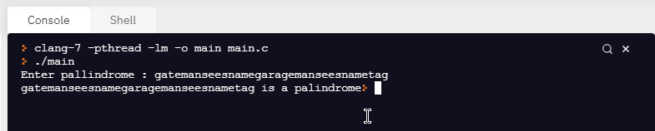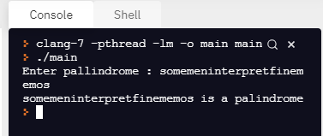

Part 3: [FOR THIS CODE, I HAD TO ADD THESE COUNTRIES TO SHOW THE OUTPUT, OTHERWISE IT WOULD SAY THEY DON’T EXIST. ]

